Test Scenarios for **Afternoon Person, Potential Saver**

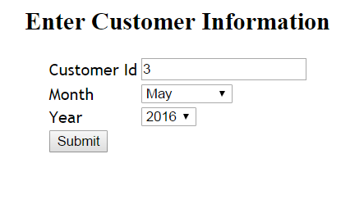

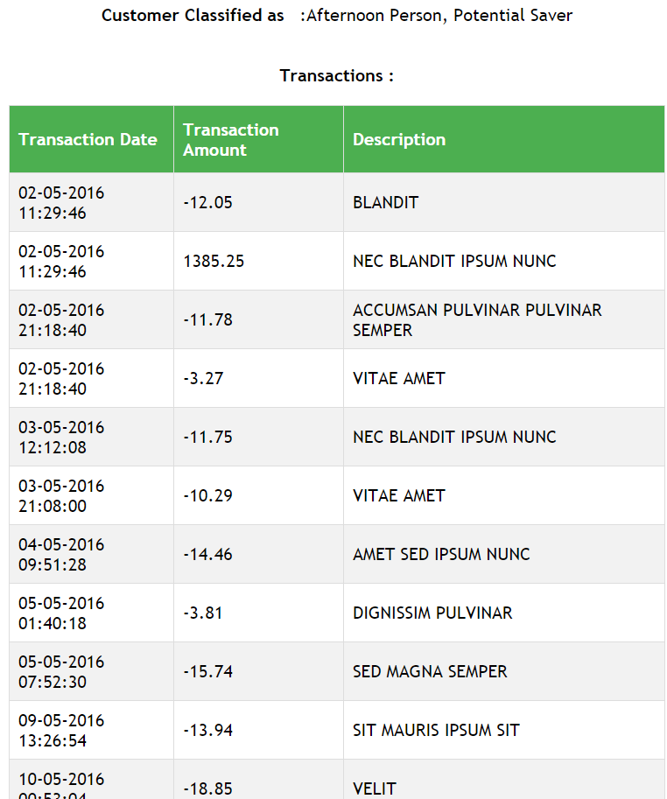

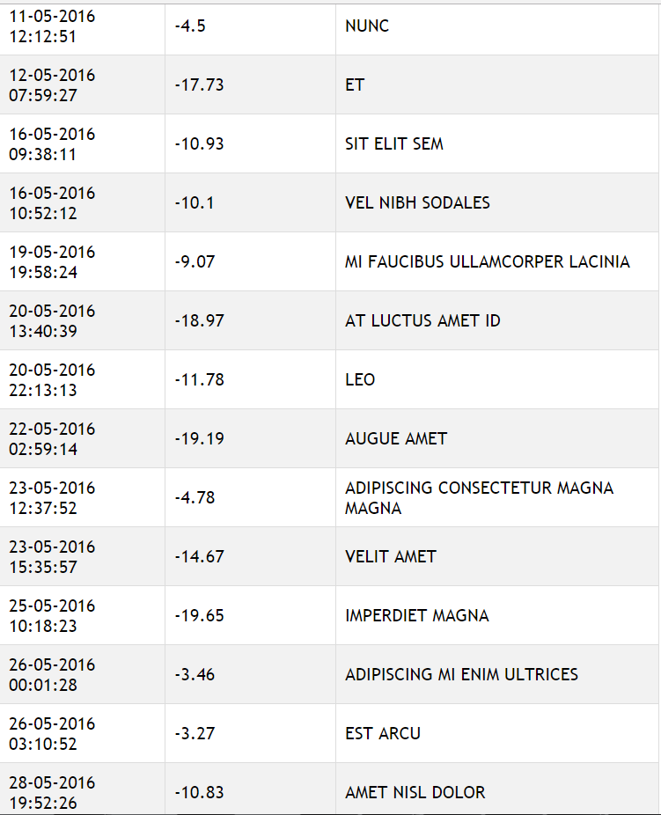

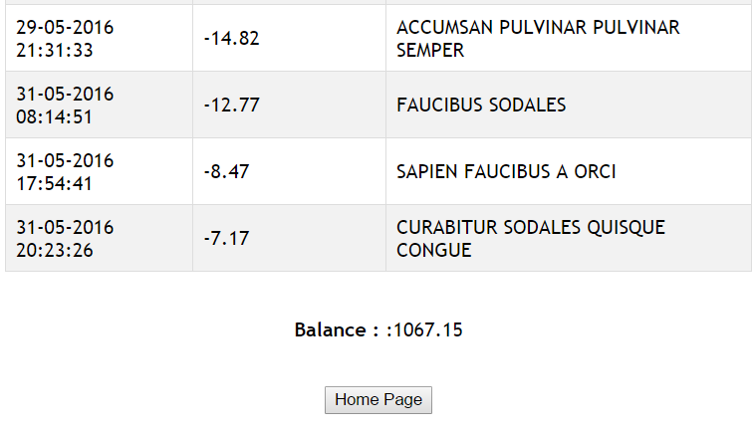

**Here is the data for above scenario**

|  |  |  |  |
| --- | --- | --- | --- |
| CustomerId | Date | Amount | Description |
| 3 | 10/05/2016 12:53:04 AM | -18.85 | VELIT |
| 3 | 11/05/2016 12:12:51 PM | -4.5 | NUNC |
| 3 | 12/05/2016 7:59:27 AM | -17.73 | ET |
| 3 | 16/05/2016 10:52:12 AM | -10.1 | VEL NIBH SODALES |
| 3 | 16/05/2016 9:38:11 AM | -10.93 | SIT ELIT SEM |
| 3 | 19/05/2016 7:58:24 PM | -9.07 | MI FAUCIBUS ULLAMCORPER LACINIA |
| 3 | 2/05/2016 11:29:46 AM | -12.05 | BLANDIT |
| 3 | 2/05/2016 11:29:46 AM | 1385.25 | NEC BLANDIT IPSUM NUNC |
| 3 | 2/05/2016 9:18:40 PM | -11.78 | ACCUMSAN PULVINAR PULVINAR SEMPER |
| 3 | 2/05/2016 9:18:40 PM | -3.27 | VITAE AMET |
| 3 | 20/05/2016 1:40:39 PM | -18.97 | AT LUCTUS AMET ID |
| 3 | 20/05/2016 10:13:13 PM | -11.78 | LEO |
| 3 | 22/05/2016 2:59:14 AM | -19.19 | AUGUE AMET |
| 3 | 23/05/2016 12:37:52 PM | -4.78 | ADIPISCING CONSECTETUR MAGNA MAGNA |
| 3 | 23/05/2016 3:35:57 PM | -14.67 | VELIT AMET |
| 3 | 25/05/2016 10:18:23 AM | -19.65 | IMPERDIET MAGNA |
| 3 | 26/05/2016 12:01:28 AM | -3.46 | ADIPISCING MI ENIM ULTRICES |
| 3 | 26/05/2016 3:10:52 AM | -3.27 | EST ARCU |
| 3 | 28/05/2016 7:52:26 PM | -10.83 | AMET NISL DOLOR |
| 3 | 29/05/2016 9:31:33 PM | -14.82 | ACCUMSAN PULVINAR PULVINAR SEMPER |
| 3 | 3/05/2016 12:12:08 PM | -11.75 | NEC BLANDIT IPSUM NUNC |
| 3 | 3/05/2016 9:08:00 PM | -10.29 | VITAE AMET |
| 3 | 31/05/2016 5:54:41 PM | -8.47 | SAPIEN FAUCIBUS A ORCI |
| 3 | 31/05/2016 8:14:51 AM | -12.77 | FAUCIBUS SODALES |
| 3 | 31/05/2016 8:23:26 PM | -7.17 | CURABITUR SODALES QUISQUE CONGUE |
| 3 | 4/05/2016 9:51:28 AM | -14.46 | AMET SED IPSUM NUNC |
| 3 | 5/05/2016 1:40:18 AM | -3.81 | DIGNISSIM PULVINAR |
| 3 | 5/05/2016 7:52:30 AM | -15.74 | SED MAGNA SEMPER |
| 3 | 9/05/2016 1:26:54 PM | -13.94 | SIT MAURIS IPSUM SIT |